March 11, 2012 –Third Sunday in Lent – Stewardship II
With All Your Soul - Holy Lovesickness
Isaiah 62:4-5 and Luke 10:25-28

Last Sunday we focused on loving God “with all our heart”. Loving God with all our heart may seem all-inclusive, but God is asking us to go even deeper…deep enough to touch our souls.

In a woman’s Bible study some 30 plus years ago one of the ladies shared a recurring dream she had. It seems she would be walking along some life scene to suddenly find herself standing naked before God. Our group’s response to her was that such dreams often represent our fear of embarrassment and shame. Most of us have had at least one dream in our life, usually just before some speaking engagement or public event that would put us “out front”, so to speak. But our assurances didn’t seem to bring her comfort, or lessen the recurrence of the dream. As she wrestled with her discomfort and what the message God might have for her, she discovered a profound truth, along with a deep sense of peace. We all stand before God with nothing to hide behind! We stand before God, the Righteous One, the Creator and Judge of all, stripped of any pretense of righteousness on our own part.

Revelation 6:15-17 describes it this way, “Then the kings of the earth, the princes, the general, the rich, the mighty and every slave and every free man hid in caves and among the rocks of the mountains. They called to the mountains and the rocks, ‘fall on us and hide us from the throne and from the wrath of the Lamb! For the great day of their wrath has come, and who can stand?’”

Who can stand? Not one of us can stand on our own merit, even the seemingly righteous. Mark Twain announced that after having spent a lot of time with “good people” he could understand why Jesus preferred to spend his time with tax collectors and sinners. He was not the first to observe the Christian’s hard-earned reputation for being “mean spirited and uncompassionate.”

So where is our peace? How did this lady friend in our prayer group find comfort and assurance? We are loved and forgiven! Standing before God as naked as Jay birds, stripped of all pretenses, is how we all come before God. The Apostle Paul puts it this way in I John 2:1-2: “My dear children, I write this to you so that you will not sin. But if anyone does sin, we have one who speaks to the Father in our defense – Jesus Christ, the Righteous One. He is the atoning sacrifice for our sins, and not only ours, but for the sins of the whole world.”
In my seventh grade class so many years ago our teacher used a mock trial to help us understand the legal system. My role was as prosecuting attorney and we won the case, but it left a lasting impression on me. First off, law school wouldn’t be for me. One look at the walls of books to be read settled law as a career choice for me, even though doing the exercise was really fun. ☺

Second, and more importantly, the defense attorney knew his client was guilty, but had to defend him anyway. This is what Christ does for us. Jesus knows we are guilty. Some of us may be more repentant than others, but we are all guilty. And yet Jesus is willing to stand before God, the eternal judge, and defend us! Jesus is willing to take the death penalty for us so that we might go free! We don’t deserve a “not guilty” verdict, or a plea bargain, or lesser sentence do to our insanity…yet we get to go free! All other religions call on believers to work their way to righteousness and eternity. We believe that God’s grace goes beyond anything we deserve.

Here is where stewardship enters in. Remember that stewardship is the attitude of a Christian toward his or her possessions. Stewardship is the recognition that God is owner of all and therefore everything we have and are is a sacred trust from God. Stewardship puts God at the center of our lives. Loving God with all our heart seems easy compared to loving God with “all our soul”. Heart loving is almost ritualistic. Heart loving is head knowledge. Heart loving is easily seen in service, regular worship attendance, and putting money in the offering plate. But loving God with all our soul is intimacy. Loving with all our soul touches the longings of our heart for love itself, and unites us with the longing of God to be in relationship with us.

We begin this deeper soul love with the assurance of God’s forgiveness of us through what was done by Christ on the cross. This is where the romance begins. God has placed in every heart a craving to be pursued, delighted in and enjoyed – first by our family, then by friends and ultimately by God. It is such an integral part of our identity that we become emotionally crippled when we feel rejection or shame. We want to be loved. We need to be loved.

Two Sundays ago we talked about covenant and the symbolism of the communion cup with the Jewish betrothal and wedding ceremony. It is not a coincidence that Jesus chose a cup of wine to symbolize his love for us. The cup symbolized the couples love and devotion, which once crushed under the heal of the groom, could never be shared by another. Much of the symbolism for entering the kingdom is that of a wedding and the intimate bond of grace beyond any understanding…agape love. Jesus wants our relationship to be taken as seriously as a marriage vow should be taken before God.

This is one of many reasons conservatives rage so against divorce and desire a traditional definition of marriage. Something gets lost when we break the covenant between two loving human beings that suggests it’s also alright to slack off on our covenant with God.

There is such wonder and awe in our relationship with God. We really need to experience this sense of wonderment in the very core of our being, our souls. Without this sense of awe, we become spiritually bored. A spiritually bored church is a weak and vulnerable church. God wants us to respond to Christ in allowing him to unveil the beauty that is only possible through Him. The real Christ is fascinating, beautiful, challenging, steadfast, yet mysterious. Think about it. We worship One who possesses transcendent beauty and compassion! There is no human definition of beauty and devotion that can adequately describe God in Christ. The seraphim gaze on him and cry out, “Holy! Holy! Holy!” because they are stunned by His beauty. Our soul mate is indescribably beautiful!

(project image – keep it up until after paragraph on Queen Elizabeth)

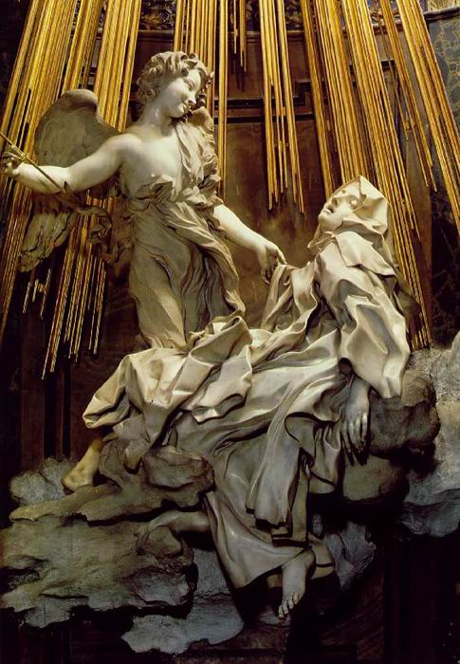

Being an art student, I’ve always loved the sculpture “The Ecstasy of St. Theresa”. As a devoted nun, Theresa found her relationship with God to be excruciatingly loving and painful all in the same moment – the ultimate orgasmic experience, if we put it in mortal terms.

How are we to be good stewards of such a beautiful gift as the grace given to us by such a loving helpmate? The movie about Queen Elizabeth gives us another example. Young Elizabeth was a Protestant in a Roman Catholic world. When her sister asked her to rule under the Pope, Elizabeth insisted she could only rule by her conscience. When the throne finally fell to Elizabeth, the responsibility overwhelmed her. Elizabeth’s trusted advisor suggested the people needed something visible to believe in and perhaps they could believe in her. With all compassion and duty, Elizabeth sacrificed her whole life to become their devoted leader, the Virgin Queen Elizabeth, stewardess of the leadership God called her to.

Can we live and serve God with as much compassion and devotion? We long to know and be known by God. This is a gift of intimacy given to us by God. We are of great value to God. Because of our value we are invited into this mysterious realm of divine knowledge. But intimacy is reciprocal, it is not one sided. While God has knowledge of all our secrets, we have knowledge of some of God’s secrets. God understands the human soul in ways we only begin to understand. Through Christ – God in the flesh - Immanuel, God understands our pain and struggles, our sin and our shame, our shattered hopes and dreams. Because God understands us so well He treats us with honor as we walk together through all the seasons of our life. This is the only marriage covenant whereby the two can truly become one. What do we do with this covenant union? How are we to be good stewards of something so humanly impossible?

Simone Weil diagnosed the human predicament in this way: “The danger is not that there is no bread, but that we have convinced ourselves that we are not hungry.” We might even add in this generation that we have convinced ourselves we need to diet! Jesus said, “I am the bread of life; those who come to me will not hunger, and those who believe in me will never thirst.” Jesus’ carbs, His bread, is the only one that we should be feeding on constantly.

Stewardship is the gift of ourselves to God, the only gift that is truly ours to give. Many a congregation uses the prayer found on page #607 in the hymnal to begin the New Year: A Covenant Prayer in the Wesleyan Tradition. Let’s turn to page #607 and read this prayer together as we renew our vow of love for God through Christ by the power of the Holy Spirit:

#607
I am no longer my own, but thine.
Put me to what thou wilt; rank me with whom thou wilt.
Put me to doing, put me to suffering.
Let me be employed by thee or laid aside for thee,
Exalted for thee or brought low by thee.
Let me be full, let me be empty.
Let me have all things, let me be nothing.
I freely and heartily yield all this to thy pleasure and disposal.
And now, O glorious and blessed God,
Father, Son and Holy Spirit,
Thou are mine, and I am thing. So be it.
And the covenant, which I have made on earth, let it be ratified in heaven.
Amen

